CSS Flexbox:

Flexbox, short for Flexible Box Layout, is a CSS (Cascading Style Sheets) module that provides a flexible way to layout and align elements within a container. It is designed to efficiently distribute space among items in a container, even when their sizes are unknown or dynamic.

The flexbox or flexible box model in CSS is a one-dimensional layout model that has flexible and efficient layouts with distributed spaces among items to control their alignment structure i.e., it is a layout model that provides an easy and clean way to arrange items within a container. Flexbox can be useful for creating small-scales layouts & is responsive and mobile-friendly.

Example:

There are 2 main components of the Flexbox:

Flex Container: The parent “div” which contains various divisions is called a flex container.

Flex Items: The items inside the container “div” are flex items.

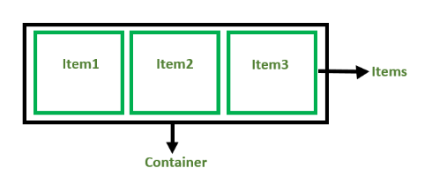

CSS Flex container:

A flex container is an HTML element that serves as a parent for a set of child elements. By applying CSS display property with the value of **flex** or **inline-flex** to the container, it becomes a flex container and enables the use of flex box layout.

The flex container properties are:

1. flex-direction
2. flex-wrap
3. flex-flow
4. justify-content
5. align-items
6. align-content

**Flex-direction:**

The flex-direction property defines in which direction the container wants to stack the flex items.

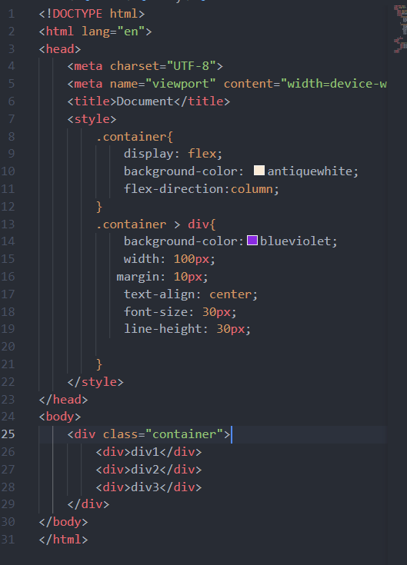

Output:

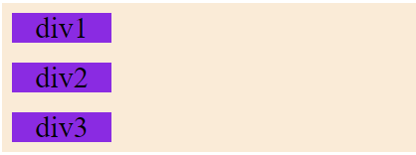

Flex wrap:

The flex-wrap property specifies whether the flex items should wrap or not.

Example:

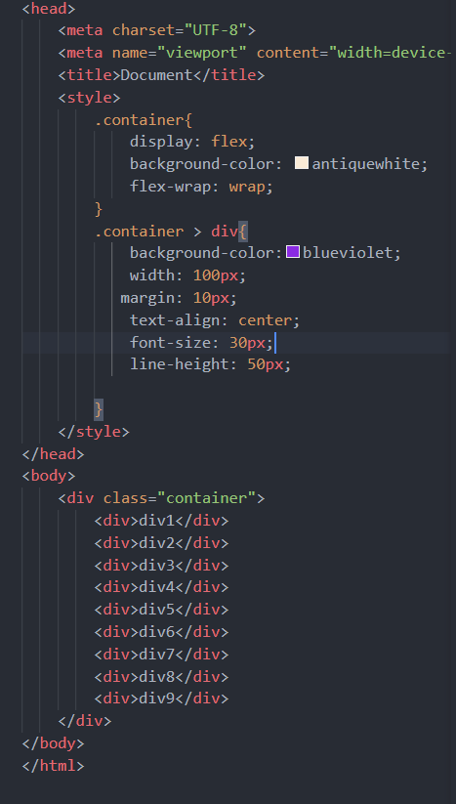

Output:

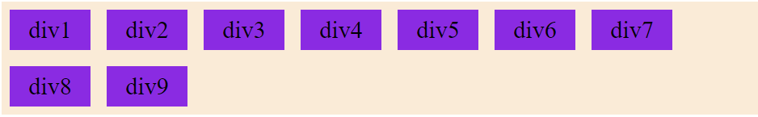

Flex flow:

The flex-flow property is a shorthand property for setting both the flex-direction and flex-wrap properties.

Example:

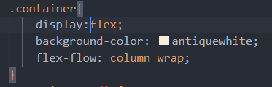

Justify content:

The justify-content property is used to align the flex items.

Example:

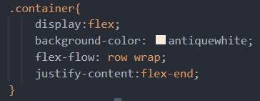

Output:

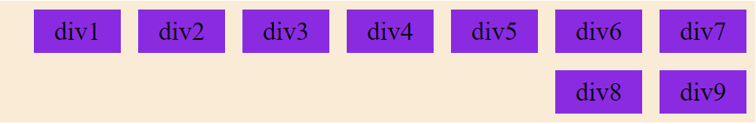

Align items:

The align-items property is used to align the flex items.

Example:

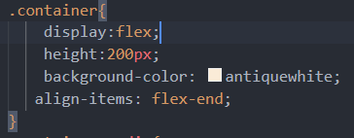

Output:

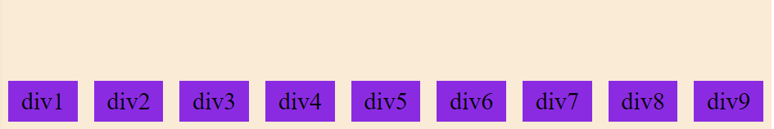

Align content

The align-content property is used to align the flex lines.

Example:

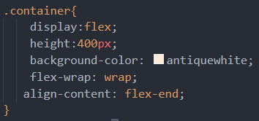

Output:

